**How To Make Really Good Restaurant-Style Ramen at Home**

A brief history of the popular Japanese dish, and tips for making your own.

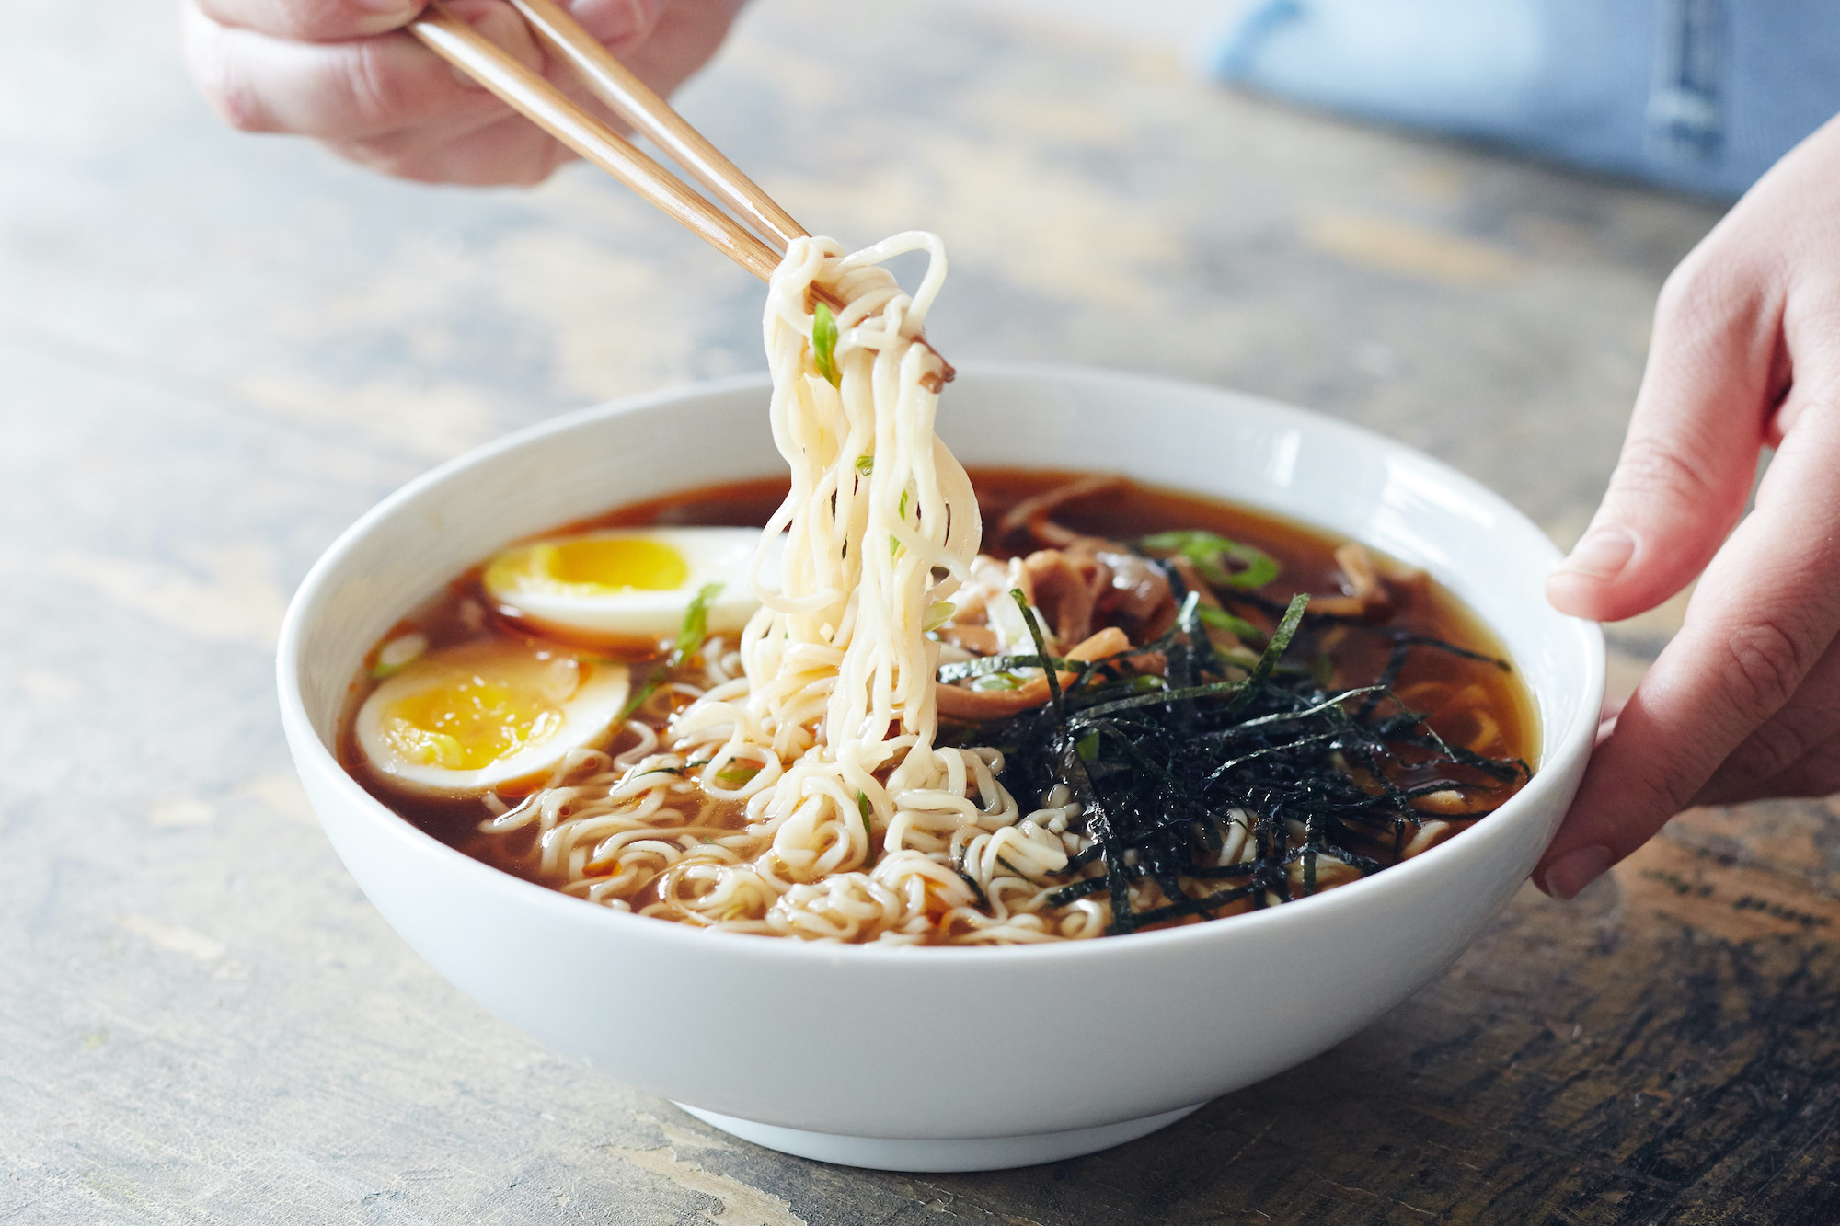

[Ramen](https://en.wikipedia.org/wiki/Ramen) is a Japanese soup, by way of Chinese noodles, that has become an American obsession. Not only have ramen noodles become part of our cultural lexicon in their ubiquitous dried mass-produced packets that sustained a generation of latch-key kids and college students, but they also grew to a burgeoning restaurant sub-culture of scavenger-hunt ramen shop tours and enthusiastic slurping.

With this recipe, we’re exploring how to do that enthusiastic slurping at home. We’ll tackle the important components of ramen — broth, seasoning, noodles, and toppings — with respect to our obsession but with a bit of grace and ease.

**Why This Method Is the Best for Most Home Cooks**

At its most basic, ramen is a soup of well-seasoned broth and noodles. Toppings like meat and eggs help make the bowl a meal, but they’re not where we’ll put our efforts in this recipe. Here, we’re concentrating on a richly flavored chicken broth and selecting the best noodles.

**A Brief Look at Our Relationship with Ramen**

Ramen noodles are actually a Chinese invention that grew roots in Japan. The bouncy ramen noodles gained popularity in the 1930s as Chinese immigrants began cooking in soba shops. The blending of Chinese noodles with Japanese broth making and eating rituals gave birth to many modern styles, with ramen shops and noodle carts becoming fixtures of Japanese dining. During World War II, push carts and street vendors were made illegal as many ingredients were rationed, and ramen nearly went extinct.

American ramen shops were likely born around this time as well, as many Japanese noodle makers left the country during the post-war economic downturn. While these 1960s-born ramen shops might not have seen the popularity that more modern ramen shops have today, it’s worth noting that most of these shops outlasted the diner fare also popular during this era.

At the same time, instant ramen was also introduced to America, marketed as healthy food to busy families. Oodles of Noodles, Cup of Ramen, and products of their ilk didn’t see fame until the 1980s. The ’80s also saw the advent of Japanese “ramen tours” that became, and remain, a popular sightseeing expedition for hungry American travelers.

Culturally speaking, ramen shops are one of the few fast food icons to avoid franchise conglomeration with a simple system of noren ramen. Loosely translated to mean branch shops, ramen shop keepers are reputed to teach employees their ramen recipes, then send these employees off to open their own shops after just a few years of service. This is good for ramen-lovers, but also means that ramen recipes, methods, and traditions have morphed slightly, like a long game of telephone over the last two decades in America.